Template for Evidence(s)
UI GreenMetric Questionnaire

University : ...
Country : ...
Web Address : …
SAMPLE
[6] Education and Research (ED)

[6.20] Impact of Eduaction and Research programs in supporting the Sustainable Development Goals (SDGs)

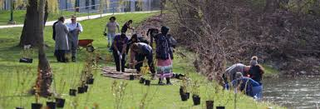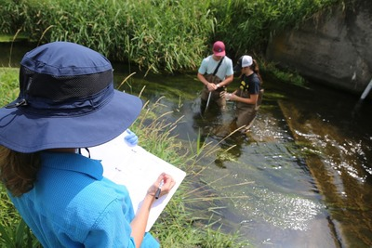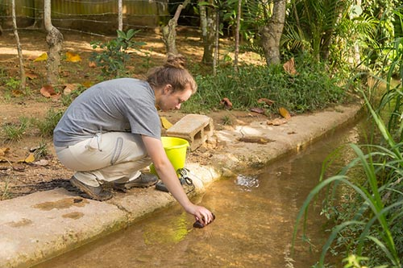
Example

Description:
(Please describe Impact of Setting and Infrastructure programs in supporting the Sustainable Development Goals. You can describe more related items if needed.)
The university has undertaken a wide range of education and research programs that contribute significantly to the achievement of the 17 Sustainable Development Goals (SDGs). These initiatives demonstrate a strong institutional commitment to sustainability integration across teaching, learning, innovation, and community engagement. Key programs include:
- Integration of sustainability themes across the curriculum in various disciplines, including environmental science, engineering, economics, public health, and social sciences.
- Development of interdisciplinary programs and courses focused on climate change, energy transition, circular economy, and sustainable development.
- Establishment of dedicated research centers, labs, and think tanks addressing key sustainability challenges such as renewable energy, biodiversity, water management, and urban resilience.
- Annual publication of sustainability-related research outputs, including peer-reviewed journals, books, policy briefs, and innovation patents.
- Provision of sustainability-focused scholarships, thesis grants, and funding support for student-led research and capstone projects.
- Community-based learning and participatory action research in collaboration with local governments, industries, and NGOs to solve real-world environmental issues.
- Organization of conferences, workshops, and summer schools on SDG-related themes to foster knowledge exchange and interdisciplinary dialogue.
- Implementation of environmental literacy campaigns to raise awareness among students, staff, and the broader community.
- Promotion of green campus living labs, where students and researchers co-develop and pilot sustainability innovations on campus.
- Partnerships with international academic networks to scale up research collaborations and share best practices on education for sustainable development.
These efforts directly support SDGs 3, 4, 5, 6, 7, 9, 11, 12, 13, 15, and 17, and contribute indirectly to the remaining goals, including:
- SDG 3 – Enhancing health and well-being through applied public health research
- SDG 4 – Providing quality education that empowers learners for sustainability
- SDG 5 – Promoting gender equality through inclusive academic opportunities
- SDG 6 – Advancing water research and infrastructure innovation
- SDG 7 – Driving clean energy solutions through academic inquiry
- SDG 9 – Supporting innovation and sustainable industrialization
- SDG 11 – Enabling sustainable urban planning through applied research
- SDG 12 – Encouraging responsible production and consumption patterns
- SDG 13 – Promoting climate science and adaptation strategies
- SDG 15 – Conserving ecosystems through environmental research
- SDG 17 – Building academic partnerships for global sustainable development
Additional evidence link (i.e., for videos, more images, or other files that are not included in this file):

